Deciefer Cyber Security India Pvt Ltd
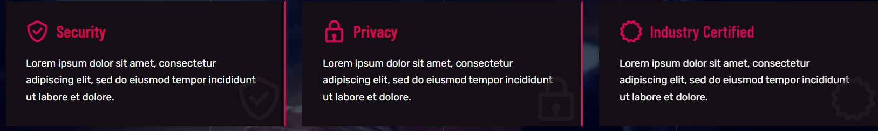

- Under Security Section
Security is the practice of protecting digital systems, networks, and data from unauthorized access, damage, or theft.
- Under Privacy Section
Privacy in cybersecurity refers to the protection of an individual's personal information and data from unauthorized access or disclosure.
- Under Industry Certified Section
Industry certifications help professionals advance their careers and demonstrate their competence in specialized areas.
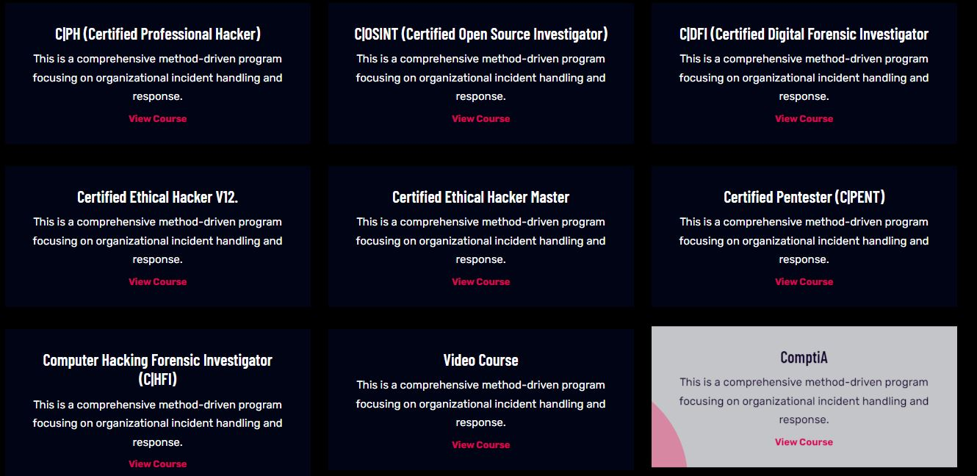
- CPH :
Certified Professional Hacker play a crucial role in enhancing cybersecurity by identifying weaknesses and helping organizations proactively secure their systems, making them a valuable asset in the ongoing battle against cyber threats.

